Testing scheme:

getSmileVol(curve, Ks)

% 1. check invalid inputs;

Input K < 0.

% 2. check whether the plot of a smile curve look smooth;

Utilize function testPlotVolcurveK2D.

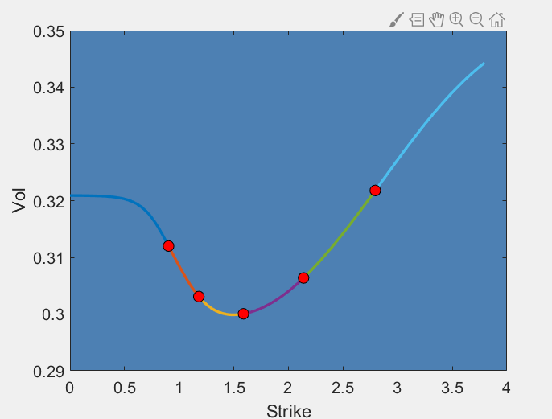

% 3. check 1st deriv(continuous) and 2nd deriv(natural) at K1 and KN.

1st derivatives are continuous at K1 and KN (smooth).

2nd derivatives are zero at K1 and KN (natural boundaries).